Module 5 Assignment  
  
Q1. Fork an existing repository created during the course  
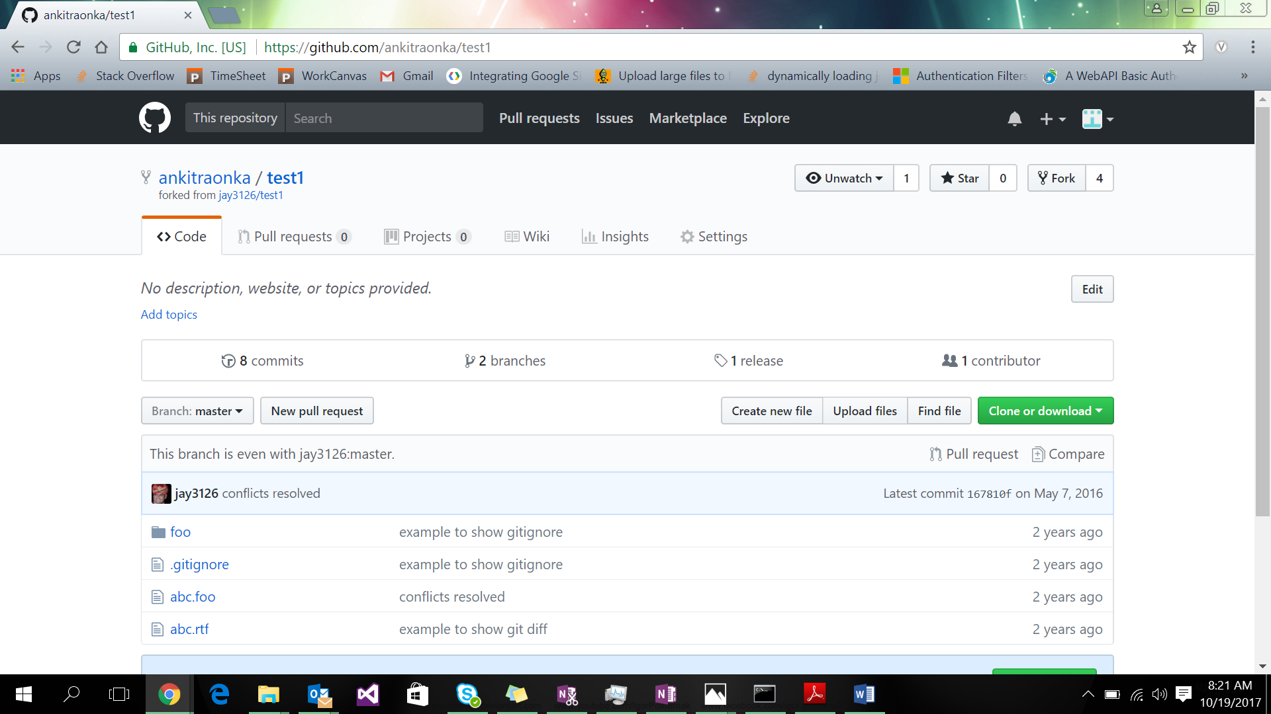

Q2. Clone the repository from the forked repository onto local machine

A2. git clone <repositoryUrl>

Q3. Make the changes and push the changes to the remote repository

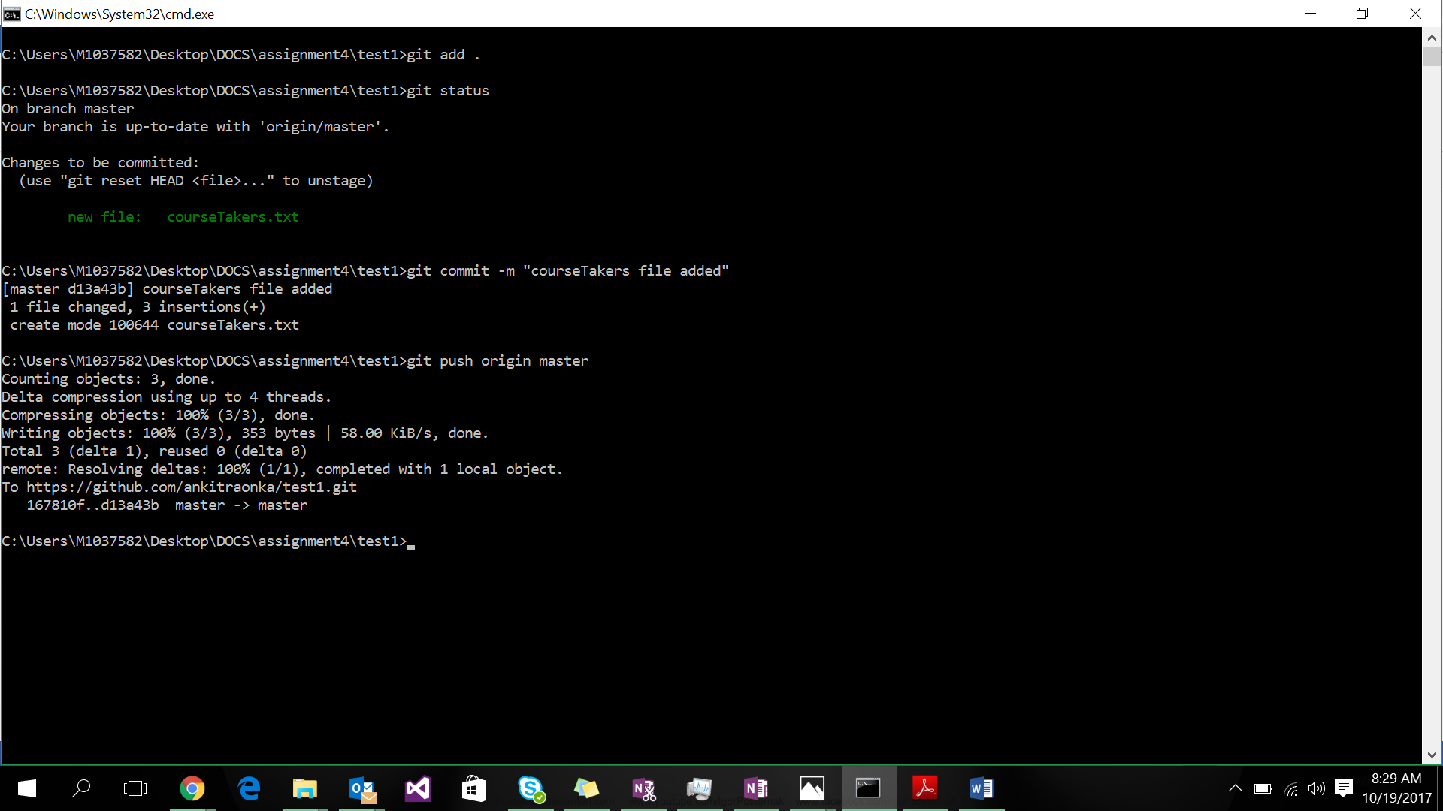

Q4. Create a pull request and create a discussion to merge the changes to the central repository

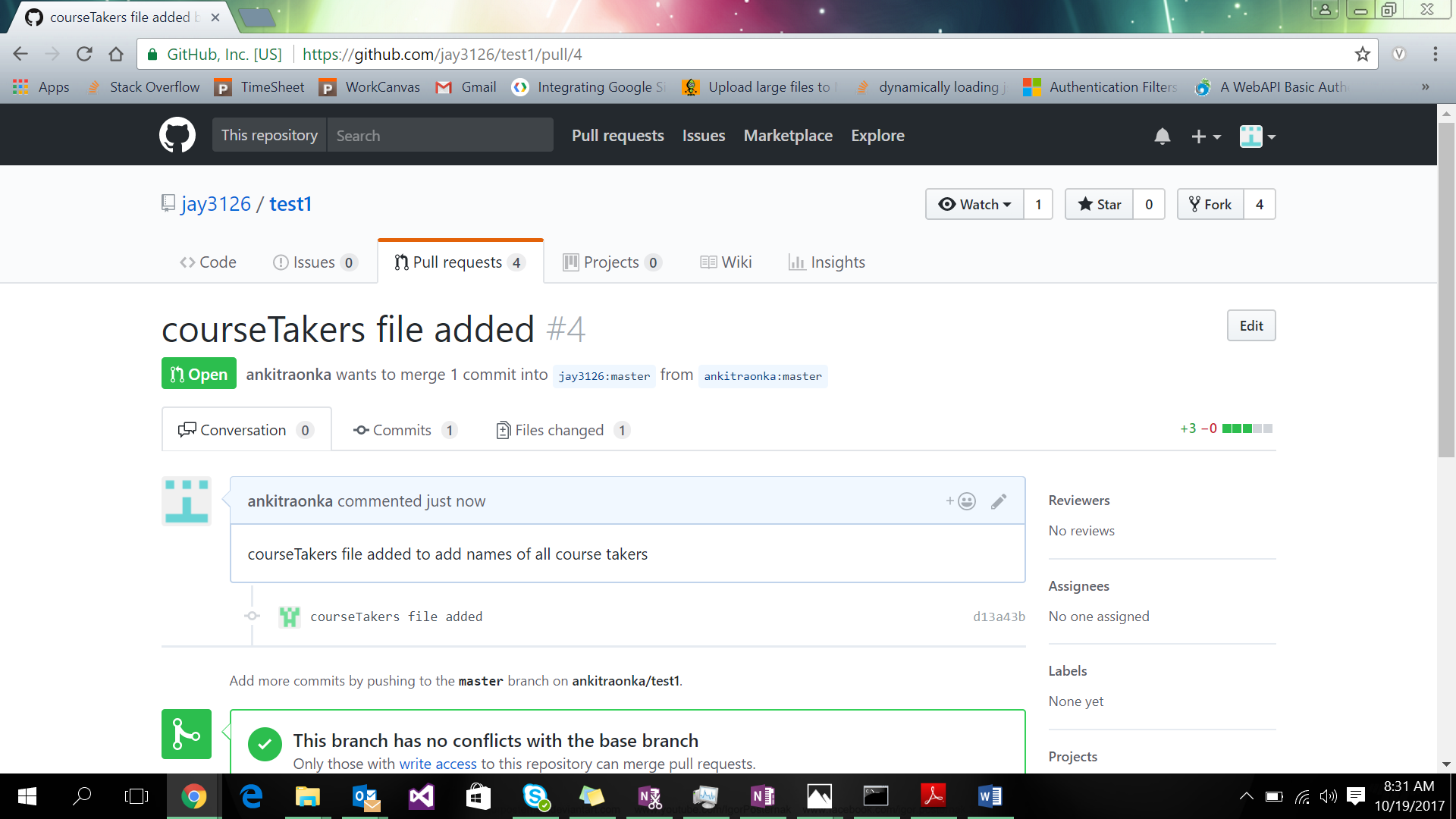

Q5. Fork from different repository and try to merge the pull request from other collaborators

